

**BIO DATA**

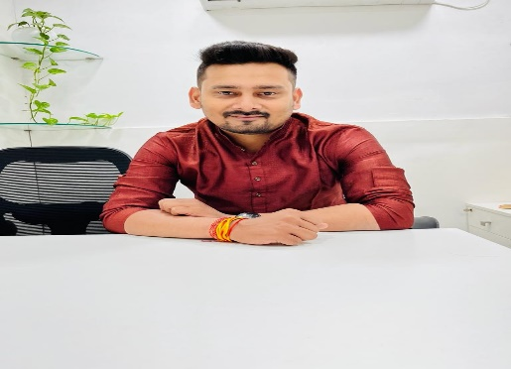

**PERSONAL DETAILS:**

Name : Abhishek Kumar

Caste : Kushwaha

Gotra : Kashyap

DOB : 03.10.1994

Place of Birth : Jamshedpur

Height : 5’10”

Complexion : Fair

Marital Status : Single

**EDUCATION:**

10th : ICSE BOARD from Church School, Beldih, Jamshedpur 2011

12th  : ICSE BOARD from Rajendra Vidyalya, Jamshedpur 2011-2013

Graduation : B.Com from Jain College, Jamshedpur 2013-2016

Post-Graduation : MBA Marketing & Finance from Department of Management

Science of Pune (PUMBA), Pune University, Pune 2016-2018

**Occupation:** Manager in ICICI Bank

Location : Raipur (C.G)

Language : English/Hindi

**FAMILY DETAILS:**

Grand Father Name : Late Vijay Singh

Father Name : Sri Raj Kumar Singh (Employed)

Occupation : Tata Steel Ltd. (Jamshedpur)

Mother Name : Smt. M. B. Singh

Occupation : Homemaker

Siblings : No

Present Address : South Park, Bistupur, Jamshedpur (Jharkhand)

Permanent Address : At Bagbera Basti (Bazar Tola), Jamshedpur (Jharkhand)

Contact Number : 9430720662